***2nd Sunday of Epiphany***

***January 19, 2025***

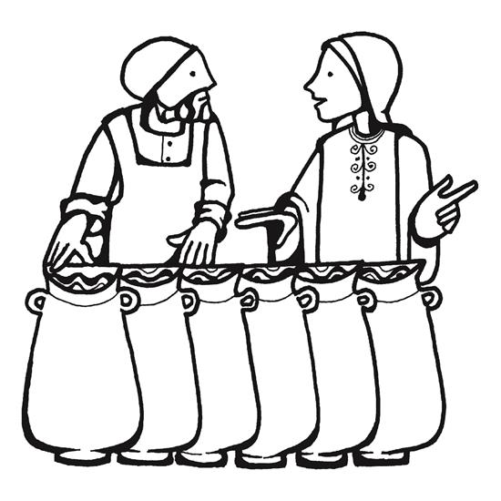

***Lutheran Church of the Good Shepherd***

***383 Old North Rd.***

***Kingston, RI 02881***

***Reverend Dennis Kohl, Pastor***

***Heather Skidds, Minister of Music***

***Welcome to Our Visitors***

In our busy world, we thank God for many things, especially your presence here. We consider it a blessing to have you among us as we gather together as people of God!

We love having guests (and celebrating your return as friends) and want to make sure you always feel welcomed.   If you’re part of another community, we look forward to hearing all about it, and we look forward to welcoming you back when you can visit again!

Sunday is a time to unplug from our busy, distracted lives, and turn back to our God.  Our worship service offers God’s gifts of Liturgy (the order of worship), God’s Word (through Scripture and Sermon), Prayer, and the Sacrament of Holy Communion.

**We are** **a “Reconciling in Christ” church of the ELCA**.  It means that we affirm + accept all people regardless of age, race, ethnicity, legal status, economic situation, sexual orientation, gender identity, marital status, physical or emotional conditions, and whatever else we didn’t list here.  **We believe that God creates us ALL in the image of God, and loves us unconditionally,** and helps us to do the same with everyone.  **We also believe** God desires that everyone should have the opportunity to participate in the life and worship of a faith community.  **We’re glad you’re here!**

**Assistants for today- Assisting Minister-** Marie Bender Lee

**Lector**- Annie Senerchia

**Greeter/Usher**- Barbara & Bruce Smith

**Communion Assistant**- Kris Bacon

**Altar set up**- Karen Amitrano

**Acolyte-** Savannah Clunan

**Assistants for 1-26-** **Assisting Minister-** Kris Bacon

**Lector**- David Nunez

**Greeter/Usher**- Riitta Passananti/Molly Palmer

**Communion Assistant**- Karen Amitrano

**Altar set up**- Annie Senerchia

**Acolyte-**

**+GATHERING+**

**Prelude-** We Are many Parts

*Stand*

**Confession and Forgiveness**

*All may make the sign of the cross, the sign that is marked at baptism, as the presiding minister begins.*

Blessed be the holy Trinity, ☩ one God, our creator, our protector,

our wellspring of life. **Amen.**

Trusting that God receives our words and the meditations of our hearts, let us confess our sin.

*Silence is kept for reflection.*

Merciful God,

**you speak blessing and compassion into the world.**

**Forgive us for the ways we act**

**with judgment, cruelty, or indifference.**

**We ignore the needs of our neighbors;**

**we resist your call to oppose injustice;**

**we give in to scarcity and fear;**

**we assume the worst about one another.**

**Cleanse us from our faults**

**and release us from their grasp.**

**Show us your lovingkindness.**

**Restore our hearts and repair your world,**

**that we may live in Christ’s ways.**

**Amen.**

God proclaims these words of assurance:

“Do not fear, for I have redeemed you.

I have called you by name. You are mine.”

In ☩ Christ, you are forgiven.

In the Spirit, you are made free.

Refreshed by the waters of mercy,

live anew as beloved children of God.

**Amen.**

**Gathering Hymn- *ELW 462 Now We Join in Celebration***

**Greeting**

The grace of our Lord Jesus Christ, the love of God, and the communion of

the Holy Spirit be with you all. **And also with you**.

**Glory Be To God**

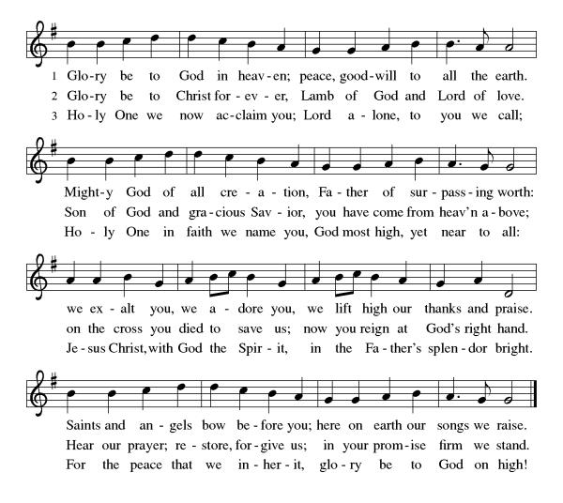

The Lord be with you. **And also with you.**

**Prayer of the Day:** Let us pray

Lord God, **source of every blessing, you showed forth your glory and led many to faith by the works of your Son, who brought gladness and salvation to his people. Transform us by the Spirit of his love, that we may find our life together in him, Jesus Christ, our Savior and Lord.**

**Amen.**

*Sit*

**First Reading: Isaiah 62:1-5**

1 For Zion’s sake I will not keep silent,  
  and for Jerusalem’s sake I will not rest,  
 until her vindication shines out like the dawn,  
  and her salvation like a burning torch.  
 2 The nations shall see your vindication,  
  and all the kings your glory;  
 and you shall be called by a new name  
  that the mouth of the Lord will give.  
 3 You shall be a crown of beauty in the hand of the Lord,  
  and a royal diadem in the hand of your God.  
 4 You shall no more be termed Forsaken,  
  and your land shall no more be termed Desolate;  
 but you shall be called My Delight Is in Her,  
  and your land Married;  
 for the Lord delights in you,  
  and your land shall be married.  
 5 For as a young man marries a young woman,  
  so shall your builder marry you,  
 and as the bridegroom rejoices over the bride,  
  so shall your God rejoice over you.

 Word of God, Word of life, **Thanks be to God**

**Psalm: Psalm 36:5-10** *to be sung*

### 

**Psalm: Psalm 36:5-10**

5 Your love, O Lord, reaches **|** to the heavens,  
  and your faithfulness **|** to the clouds.  
 6 **Your righteousness is like the strong mountains, your justice like | the great deep;**  
  **you save humankind and ani- | mals, O Lord.**  
 7 How priceless is your **|** love, O God!  
  All people take refuge under the shadow **|** of your wings.  
 8 **They feast upon the abundance | of your house;**  
  **you give them drink from the river of | your delights.**  
 9 For with you is the **|** well of life,  
  and in your light **|** we see light.  
 10 **Continue your lovingkindness to | those who know you,**  
  **and your favor to those who are | true of heart.  Amen**

**Second Reading: 1 Corinthians 12:1-11**

1 Now concerning spiritual gifts, brothers and sisters, I do not want you to be uninformed. 2 You know that when you were pagans, you were enticed and led astray to idols that could not speak. 3 Therefore I want you to understand that no one speaking by the Spirit of God ever says “Let Jesus be cursed!” and no one can say “Jesus is Lord” except by the Holy Spirit.  
  4 Now there are varieties of gifts, but the same Spirit; 5 and there are varieties of services, but the same Lord; 6 and there are varieties of activities, but it is the same God who activates all of them in everyone. 7 To each is given the manifestation of the Spirit for the common good. 8 To one is given through the Spirit the utterance of wisdom, and to another the utterance of knowledge according to the same Spirit, 9 to another faith by the same Spirit, to another gifts of healing by the one Spirit, 10 to another the working of miracles, to another prophecy, to another the discernment of spirits, to another various kinds of tongues, to another the interpretation of tongues. 11 All these are activated by one and the same Spirit, who allots to each one individually just as the Spirit chooses.

Word of God, Word of life, **Thanks be to God**

*Stand*

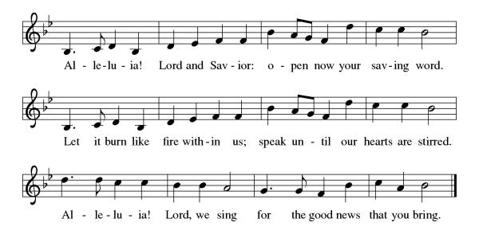

**Gospel: John 2:1-11**

The holy Gospel according to John.  
**Glory to you, O Lord.**

**Gospel: John 2:1-11**

1 On the third day there was a wedding in Cana of Galilee, and the mother of Jesus was there. 2 Jesus and his disciples had also been invited to the wedding. 3 When the wine gave out, the mother of Jesus said to him, “They have no wine.” 4 And Jesus said to her, “Woman, what concern is that to you and to me? My hour has not yet come.” 5 His mother said to the servants, “Do whatever he tells you.” 6 Now standing there were six stone water jars for the Jewish rites of purification, each holding twenty or thirty gallons. 7 Jesus said to them, “Fill the jars with water.” And they filled them up to the brim. 8 He said to them, “Now draw some out, and take it to the chief steward.” So they took it. 9 When the steward tasted the water that had become wine, and did not know where it came from (though the servants who had drawn the water knew), the steward called the bridegroom 10 and said to him, “Everyone serves the good wine first, and then the inferior wine after the guests have become drunk. But you have kept the good wine until now.” 11 Jesus did this, the first of his signs, in Cana of Galilee, and revealed his glory; and his disciples believed in him.

The Gospel of our Lord.  
**Praise to you, O Christ.**

*Sit***SERMON**

*Stand*

**HYMN OF THE DAY- *ELW 312 Jesus Come for We Invite You***

**Apostles Creed***Baptized into Christ, with the whole Church, let us confess our faith.*

**I believe in God, the Father almighty,**

**creator of heaven and earth.**

**I believe in Jesus Christ, God’s only Son, our Lord,**

**who was conceived by the Holy Spirit,**

**born of the virgin Mary,**

**suffered under Pontius Pilate,**

**was crucified, died, and was buried;**

**he descended to the dead.**

**On the third day he rose again;**

**he ascended into heaven,**

**he is seated at the right hand of the Father,**

**and he will come to judge the living and the dead.**

**I believe in the Holy Spirit,**

**the holy catholic church,**

**the communion of saints,**

**the forgiveness of sins,**

**the resurrection of the body,**

**and the life everlasting. Amen.**

**PRAYERS OF INTERCESSION  
AM:** Each petition concludes: God of grace, **receive our prayer.**

*The pastor concludes the prayers***PR:** We commend these prayers to you, O God, trusting your grace made known to all, through the Word made flesh, Jesus Christ, our Savior and Lord.

**Amen.**

**PEACE**

The peace of Christ be with you.  **And also with you.***A sign of peace and reconciliation is shared among worshippers.*

*Sit*

**Choir Anthem**- Bind Us Together

*AM sets the table*

*AM collects offering in front of altar from acolyte*

*Our offering is presented for the work of the church locally and throughout the world.*

*Stand*

**Offering Prayer**

**AM:** Let us pray: God of grace, **your love reaches to the heavens, and your abundance to the depths of the seas. Bless what we offer to your service:**

**our gifts, our abilities, and our hearts. Let us overflow with gratitude and generosity, now and always. Amen.**

**+MEAL+**

**Great Thanksgiving**

The Lord be with you.

**and also with you**

Lift up your hearts.

**we lift them to the Lord.**

Let us give thanks to the Lord our God.

**It is right to give our thanks and praise.**

*The pastor prays the preface for the congregation.*Iti Is indeed right, our duty and our joy, That we should at all times and in all places give thanks and praise to you, Almighty and merciful God Through our Savior Jesus Christ. By the leading of a star he was shown forth to all nations;

In the waters of the Jordan you proclaimed him your beloved Son, and in the miracle of water turned to wine he revealed your glory. And so, with all the choirs of angels,’ With the church on earth and the hosts of heaven,

We praise your name and join their unending hymn:

**Sanctus**

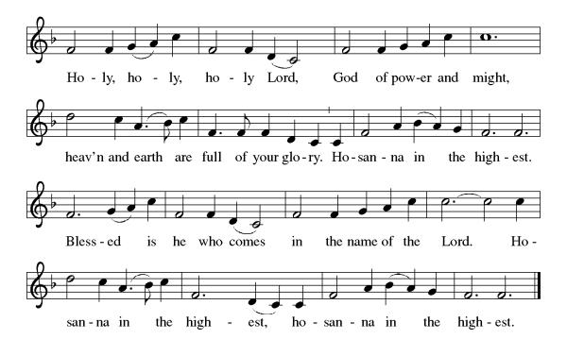

*The pastor and congregation pray the Thanksgiving at the Table.*

**Thanksgiving at the Table**

Blessed are you, O holy God…all the universe will rejoice in your holy and

life-giving light…**Amen, Come Lord Jesus**

…By your Spirit bless us and

this meal…revealing the brilliance of your Son. **Amen, Come Holy Spirit.**

Through him all glory and honor is yours, Almighty Father, with the Holy

Spirit, in your holy Church, both now and forever. **Amen**.

*Gathered into one by the holy spirit, let us pray as Jesus taught us.*

**Our Father...**

**Invitation to communion:**

In the manger and at this table, come and see what God has done for you.

*Please remain standing*

*Agnus Dei*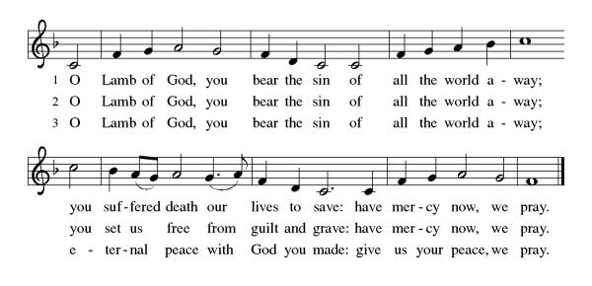**Distribution of Holy Communion***Our congregation practices eucharistic hospitality.  We believe that the resurrected Christ is truly present in the bread and wine with his gifts of life, forgiveness of sin, and salvation.  All are welcome at the Lord’s table.  Please come to the altar to receive the bread and wine.  If you are wearing a mask, remove it to eat and drink the sacrament.  If you receive the wine, take a small cup, or you may intinct the host in the chalice. Place the small cups in the baskets on either side of the altar area.  Please return to your seat by the side aisles.*

**Communion Reflection: *ELW 474 Bread of Life from Heaven***

**+SENDING+**

*Stand***BLESSING**The body and blood of our Lord Jesus Christ strengthen you and keep you in his grace.  **Amen.**

**PRAYER AFTER COMMUNION  
AM:** Let us pray. Nourishing God, **at this table you have refreshed us with holy gifts of food and drink. Strengthen us for service, and send us out to embody your good news of liberation and healing for the sake of the world. In the name of Christ we pray, Amen.**

**BENEDICTION**

The Lord bless you and keep you.

The Lord shine on you with grace and mercy.

The Lord look upon you with favor and + give you peace. **Amen.**

*Sit*

**ANNOUNCEMENTS**

*Stand*

**SENDING HYMN- *ELW 551 The Spirit Sends Us Forth to Serve***

**Dismissal:** Go in peace. Live in hope. **Thanks be to God.**

**Postlude-** Allegretto, by J. Blied

***Sundays and Seasons v.20220215.1125  
Copyright © Augsburg Fortress. All rights reserved.***

**Announcements**

**Confirmation Classes** will be held on the 1st and 3rd Sundays, following worship.

**Adult Education**, Mondays at 6:30. E-mail Pastor Kohl and he will give you the information to connect to zoom.

**Annual Congregation Meeting- Today, after Worship**

**SPIFFING UP OUR SPACE**

A proposal was submitted to the Church Council to freshen and reorganize various areas within our building. Work has begun with the cleaning and organizing of the storage closet off Anderson Hall. This week we will be working on cleaning and tidying up the kitchen and the coffee bar area. Additionally, we plan to work on the narthex and the adjoining storage area as well as the shed outside the kitchen. Any and all help is appreciated. Please see Arlene Phillips, Carolyn Hedberg, Susan Gaunt or Deb Crary if you would like to join us!

### ***Ongoing Prayers for:***

*For additions or deletions please e-mail or call the church office.789-7776, or* [*lcgsmail@gmail.com*](mailto:lcgsmail@gmail.com)

***For those who mourn:*** Our thoughts and prayers are with the Greer family, friends of Diane & Bob Guerin, who recently lost their son.

Amy Hinkle

Karin Kohl

Traci Purvis

Jessica Maynard

Bobbie Peterson

C. Duncan

Margaret Franks

Billy Wernquest

Ruth Wernquest

Holly Deutsch

Mary Jane Briggs

Bill Deutsch

Gary Durett

Natalie Schanck

Mike Carty

Barbara Smith

Eero Moisio

Phyllis Farley

Brian Mitchell

Barney

Joyce Pearson

Amy Phillipo

James Meyers

Naomi Sawyer

Karolyn Lee

Liam Varnelis

Josh Peterson

Kathy Lee

Chris Rose

Lisa Ferry  
Ellora Hendrickson

Melvin Platt

KC Christensen

Jan Briggs

Ruth McGuy

Bud Godwin

Lisa Lessman

Taylor Lessman

Joan & Sheldon Pratt

Jerry Paquin

Stanley Larson

Ellen Hedlund

Donald & Bernadine Cunnigen

Maggie Reichgott

Tucker Maute

Karen Perry

Mark Quinn

Carolyn Hathaway

Betty Hathaway

Tim Diskin

**+LOVED ONES IN THE ARMED FORCES**+ Manny Morales, Michael Bock

Matthew Kankash, Heath O’Neill, Andrew Anderson, Noah Cooper, Dan Berkowitz